The Unseen Engine of AI Product Success

A Deep Dive into Evaluations
Author: Manus AI

1. Introduction
The advent of Large Language Models (LLMs) has unlocked unprecedented opportunities for product innovation. However, the very nature of these powerful tools introduces a new set of challenges for Product Managers (PMs). Unlike traditional software with deterministic outputs, LLMs operate in a probabilistic realm, making the assessment of quality and performance a complex, multifaceted endeavor. The article, "The One Skill Every AI PM Needs (That Nobody Taught You)," compellingly argues that evaluations (evals) are the cornerstone of successful AI product development. This document expands upon the foundational concepts presented in the article, integrating insights from extensive research across industry best practices, academic publications, and expert guidance from leading AI companies.
This research paper will delve deeper into the critical aspects of AI evaluations, providing a comprehensive guide for AI Product Managers. We will explore the theoretical frameworks that underpin the challenges of LLM evaluation, dissect the practical lifecycle of building and implementing robust evaluation systems, and survey the landscape of cutting-edge tools and techniques. The goal is to equip PMs with the knowledge and strategies necessary to navigate the complexities of AI product development and build reliable, high-performing, and user-centric AI applications.

2. The Three Gulfs: Understanding the Core Challenges of LLM Evaluation
The original article introduced the "Three Gulfs" framework, a powerful mental model for understanding the inherent difficulties in evaluating LLMs. This framework, originally from the paper "Who Validates the Validators?", highlights the disconnects between the developer's intent, the data, and the model's behavior. A deeper understanding of these gulfs is crucial for any AI PM seeking to build effective evaluation strategies.

2.1. The Gulf of Comprehension: From Developer to Data
The Gulf of Comprehension refers to the challenge of understanding the vast and often messy landscape of input data that an LLM-powered product will encounter in the real world. At scale, it is impossible to manually inspect every piece of data or every model output. This creates a significant blind spot for developers and PMs.
"Just as we cannot read every input, we also cannot manually inspect every output trace generated by the pipeline to grasp all the subtle ways it might succeed or fail across the input space."
This gulf is not just about the volume of data, but also its diversity. Inputs can come in countless formats, with varying levels of clarity, and may contain unexpected patterns or edge cases. Without a systematic way to analyze and understand this data distribution, it becomes incredibly difficult to identify potential failure modes or biases in the model's behavior. For an AI PM, bridging this gulf means investing in tools and processes for data profiling, anomaly detection, and automated monitoring to gain a clearer picture of the input space.

2.2. The Gulf of Specification: From Developer to LLM Pipeline
The Gulf of Specification highlights the difficulty of translating human intent into precise, unambiguous instructions for an LLM. The prompts we write, no matter how detailed, are often a loose approximation of our true goals. The model, lacking human context and common sense, can only interpret the instructions it is given, not the underlying intent.
For example, a seemingly straightforward instruction like "summarize the key requests in this email" leaves many questions unanswered:
- How long should the summary be?
- Should it be a paragraph or a bulleted list?
- Should it include implicit requests or only explicit ones?
These ambiguities can lead to outputs that, while technically correct according to the prompt, fail to meet the user's needs. Bridging this gulf requires a rigorous and iterative approach to prompt engineering, where PMs and developers work together to refine instructions, provide clear examples, and explicitly define constraints. This process of externalizing and clarifying one's thinking is a critical, and often overlooked, aspect of building reliable AI systems.

2.3. The Gulf of Generalization: From Data to LLM Pipeline
The Gulf of Generalization addresses the model's ability to apply its learned knowledge to new and unseen data. Even with a perfectly specified prompt and a good understanding of the input data, an LLM can still fail to generalize correctly. This is because models are trained on vast but finite datasets, and they may encounter novel situations in the real world that they have not been explicitly trained to handle.
A classic example is a model that correctly extracts the sender's name from most emails but fails when the email body contains the name of a public figure, mistakenly identifying them as the sender. This is a generalization failure. The model has not learned to distinguish between the actual sender and other names mentioned in the text.
This gulf will always exist to some degree, as no model will ever be perfect. The key for AI PMs is to develop robust evaluation strategies that can identify these generalization failures, understand their root causes, and implement mitigation strategies, such as fine-tuning the model on more diverse data or adding specific guardrails to the system.
Gulf | Description | Implication for AI PMs
Comprehension | Difficulty in understanding the full spectrum of input data and model outputs at scale. | Need for robust data analysis, monitoring, and anomaly detection to identify potential issues.
Specification | The gap between human intent and the explicit instructions given to the LLM. | Requires a rigorous, iterative approach to prompt engineering and clear definition of requirements.
Generalization | The model's inability to apply its knowledge correctly to new and diverse data. | Demands comprehensive evaluation strategies to identify and mitigate generalization failures.

2.4. Visual Framework: Evaluation Complexity
The following image from Anthropic's engineering blog illustrates the complexity of evaluation systems across different agent architectures:
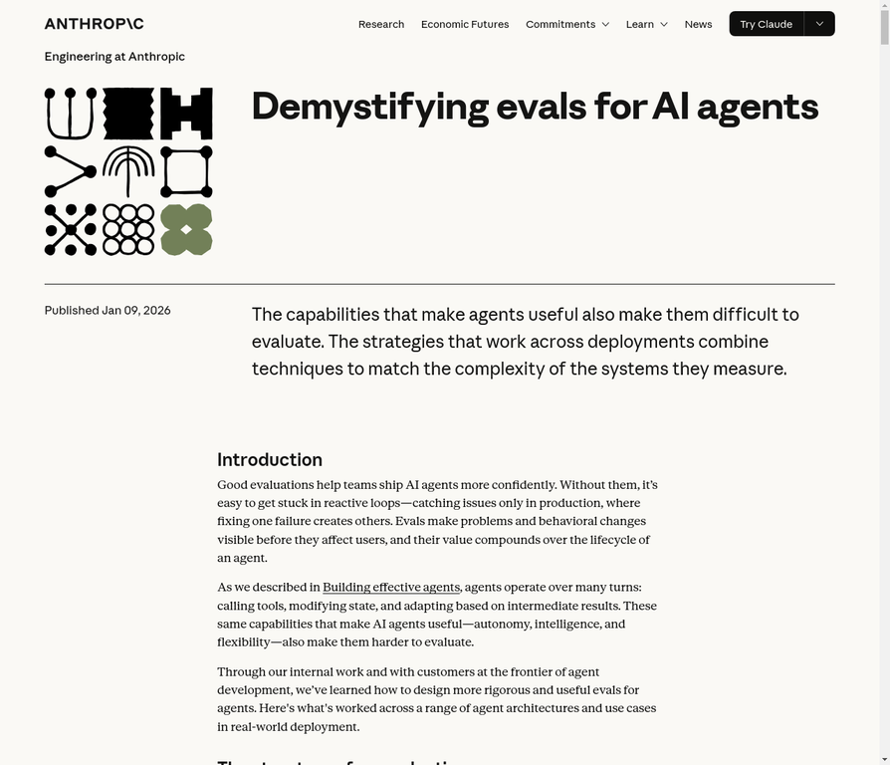

3. The LLM Evaluation Lifecycle: A Framework for Continuous Improvement
To systematically address the challenges posed by the Three Gulfs, the article proposes a three-step evaluation lifecycle: Analyze, Measure, and Improve. This iterative process provides a structured approach to understanding, quantifying, and enhancing the performance of LLM applications. Leading AI companies like Anthropic and Databricks have adopted similar cyclical methodologies, emphasizing the importance of continuous evaluation throughout the product development process.

3.1. Step 1: Analyze
The first step in the evaluation lifecycle is to qualitatively analyze the behavior of the LLM pipeline. This involves inspecting the model's outputs on a representative set of data to identify failure modes and areas for improvement. This initial, exploratory phase is crucial for developing a deep understanding of how the system is performing in practice.
During the analysis phase, the goal is to answer questions like:
- Where is the model succeeding?
- Where is it failing?
- Are there specific types of inputs that consistently cause problems?
- Are the failures related to specification issues (ambiguous prompts) or generalization issues (inconsistent performance)?
This qualitative analysis provides the raw material for the next phase of the lifecycle. The insights gained from this process will inform the development of specific, targeted evaluation metrics.

3.2. Step 2: Measure
Once potential failure modes have been identified, the next step is to develop and deploy specific evaluators (evals) to quantitatively measure their frequency and impact. This phase is about moving from anecdotal evidence to hard data. By systematically measuring performance against predefined criteria, PMs can prioritize which problems to fix first and diagnose the root causes of complex issues.
This is where the different types of evaluation metrics, which will be discussed in detail in a later section, come into play. Whether using reference-based metrics that compare outputs to a golden set or reference-free metrics that assess intrinsic qualities of the output, the goal is to create a consistent and reliable way to score the model's performance. This quantitative data is essential for tracking progress over time and making informed decisions about where to invest resources.

3.3. Step 3: Improve
The final step in the lifecycle is to make targeted interventions to improve the performance of the LLM pipeline. The insights gained from the Analyze and Measure phases will guide these improvements. This could involve:
- Prompt Engineering: Refining the instructions, adding more examples, or clarifying ambiguities to address specification issues.
- Data-Driven Efforts: Engineering better few-shot examples, refining retrieval strategies for RAG systems, or fine-tuning the model on a curated dataset of failure cases to enhance generalization.
- Architectural Changes: Modifying the overall system architecture, such as adding a post-processing step to correct common errors or implementing a different retrieval strategy.
After implementing these improvements, the cycle begins again. The updated pipeline is then re-analyzed and re-measured to assess the impact of the changes and identify new areas for improvement. This continuous, iterative process is the engine that drives the development of more reliable, effective, and user-centric LLM applications.

3.4. Industry Best Practices: Databricks Approach
Databricks has developed comprehensive frameworks for evaluating LLM applications at scale:
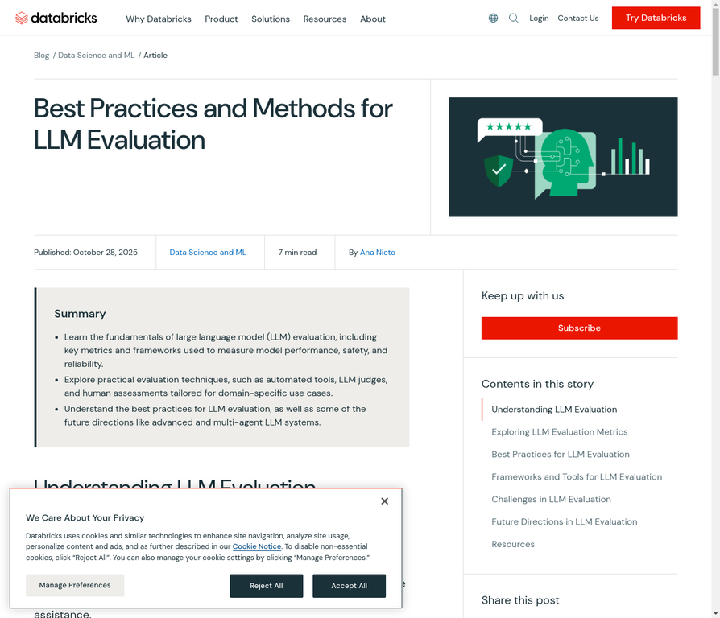

4. Prompting as a Cornerstone of Evaluation
Effective prompting is not just about getting the desired output from an LLM; it is a fundamental part of the evaluation process itself. As highlighted in the Gulf of Specification, the prompts we write are the primary interface for communicating our intent to the model. Therefore, a deep understanding of prompting fundamentals is essential for any AI PM.

4.1. The Anatomy of a Well-Structured Prompt
Research and best practices from leading AI labs like OpenAI and Anthropic have converged on a set of key components that constitute a well-structured prompt. While not every prompt needs to include all of these components, they provide a valuable framework for thinking about how to construct clear and effective instructions for an LLM.
Component | Description | Example
Role and Objective | Defines the persona the LLM should adopt and its overall goal. | You are an expert financial analyst tasked with summarizing quarterly earnings reports for a non-technical audience.
Instructions/Rules | Specific, unambiguous instructions, often using bullet points for clarity. | - Summarize the report in three sentences.  - Avoid financial jargon.  - Do not include personal opinions.
Context | The relevant background information or data the LLM needs to perform the task. | The full text of the quarterly earnings report.
Examples (Few-Shot) | One or more examples of desired input-output pairs to guide the model's response. | An example of a poorly written summary and a well-written summary of a similar report.
Reasoning Steps (Chain-of-Thought) | Instructs the model to "think step by step" to break down complex problems. | First, identify the key financial metrics. Second, compare them to the previous quarter. Third, summarize the overall trend.
Output Formatting | Explicitly defines the desired structure or format of the output. | Respond with a JSON object containing the keys: 'revenue', 'net_income', and 'eps'.
Delimiters | Clear separators to distinguish different parts of the prompt. | Using ### or XML tags to separate instructions from context.

4.2. The Iterative Nature of Prompt Refinement
Finding the perfect prompt is rarely a one-shot process. It is an iterative cycle of writing, testing, analyzing, and refining. This process is deeply intertwined with the evaluation lifecycle. As you evaluate the model's outputs, you will uncover failure modes and ambiguities that can be addressed by refining the prompt.
This iterative refinement is not just about tweaking words; it is about clarifying your own thinking. The process of writing and refining a prompt forces you to externalize your assumptions and make your requirements explicit. This is why the original article wisely advises against outsourcing prompt writing in the early stages of development. By engaging directly in the process of prompt engineering, PMs can gain a much deeper understanding of their product's capabilities and limitations.

4.3. OpenAI Evals Framework
OpenAI provides a comprehensive framework for building and running evaluations:
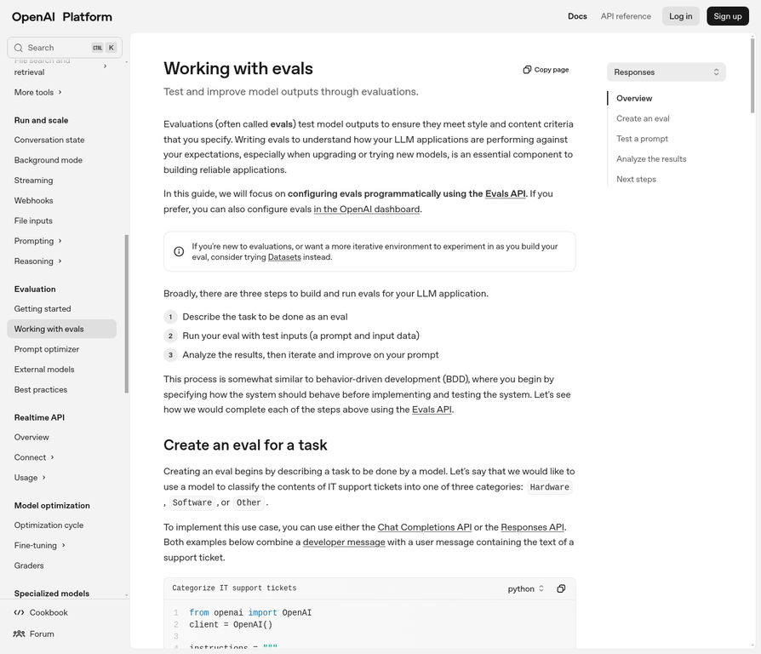

5. A Taxonomy of Evaluation Metrics
The "Measure" phase of the evaluation lifecycle is powered by a diverse set of metrics, each designed to assess different aspects of an LLM's performance. These metrics can be broadly categorized into two main types: reference-based and reference-free. Understanding the strengths and weaknesses of each category is crucial for developing a comprehensive evaluation strategy.

5.1. Reference-Based Metrics
Reference-based metrics operate on a simple principle: comparing the model's output to a known, ground-truth answer. This is akin to having an answer key for a test. These metrics are most effective when there is a single, objectively correct answer.
Metric | Description | Use Case
Exact Match | The model's output must be an exact string match to the reference answer. | Short-answer extraction, classification tasks.
BLEU | Measures the overlap of n-grams between the model's output and the reference. | Machine translation, text summarization.
ROUGE | Assesses how much of the reference content is captured in the model's output. | Text summarization, content generation.
BERTScore | Compares the semantic similarity between the model's output and the reference using contextual embeddings. | Paraphrasing, text generation.
While reference-based metrics are valuable for their objectivity and ease of automation, they have limitations. They can be too rigid for tasks where there are multiple valid outputs, and they may not capture the nuances of language, such as tone or style.

5.2. Reference-Free Metrics
Reference-free metrics, as the name suggests, evaluate the model's output based on its intrinsic properties, without a specific "golden" answer. This approach is essential for evaluating subjective or creative tasks where there is no single correct answer.
Metric | Description | Use Case
Perplexity | Measures how well a model predicts the next word in a sequence. | Language modeling, text generation.
Toxicity/Bias | Detects harmful, biased, or inappropriate content in the model's output. | Chatbots, content moderation.
Coherence | Assesses the logical flow and consistency of the generated text. | Creative writing, long-form content generation.
LLM-as-a-Judge | Uses another LLM to evaluate the quality of the model's output based on a predefined rubric. | Subjective tasks, open-ended generation.
Reference-free metrics are more flexible than their reference-based counterparts, but they can be more challenging to implement and interpret. The LLM-as-a-Judge approach, in particular, has gained significant traction as a scalable way to evaluate subjective qualities, but its effectiveness is highly dependent on the quality of the judge model and the clarity of the evaluation rubric.

6. Best Practices for Implementing a Robust Evaluation Strategy
Building an effective evaluation strategy is both an art and a science. It requires a thoughtful combination of the right metrics, the right data, and the right processes. Based on the research conducted, here are some best practices for AI PMs to follow:

Start with a Goal-Oriented Mindset
Before diving into specific metrics, clearly define what "good" looks like for your product. What are the key user needs that the LLM is supposed to address? What are the most critical failure modes to avoid? This goal-oriented approach will ensure that your evaluation strategy is aligned with your product objectives.

Use a Diverse and Representative Dataset
The quality of your evaluation is only as good as the quality of your test data. Your dataset should be diverse, representative of real-world usage, and include a wide range of edge cases and potential failure modes. By curating datasets from various sources, you can ensure coverage across multiple domains and incorporate opposing examples to enhance the evaluation process.

Combine Automated Metrics with Human Feedback
While automated metrics are essential for scalability and consistency, they cannot capture the full spectrum of human preferences and nuances. It is crucial to supplement automated metrics with human feedback, whether through in-house experts, crowdsourced annotators, or user feedback channels. This human-in-the-loop approach provides the qualitative insights that are often missed by automated systems.

Iterate and Refine
Your evaluation strategy should not be static. As your product evolves and you gain a deeper understanding of its failure modes, you should continuously iterate and refine your evaluation metrics and processes. The Analyze-Measure-Improve lifecycle is a continuous loop, not a one-time process.

7. The Future of AI Evaluations: A Glimpse into What's Next
The field of AI is evolving at a breathtaking pace, and the methods for evaluating AI systems are evolving along with it. As we look to the future, several key trends are emerging that will shape the next generation of AI evaluations:

Multi-modal Evaluations
With the rise of multi-modal models that can process and generate text, images, and audio, evaluation strategies will need to expand to assess performance across all of these modalities. This will require new types of metrics and new ways of thinking about what constitutes a "good" output.

Multi-agent System Evaluations
As AI systems become more complex, we will see the rise of multi-agent systems where multiple AIs collaborate to achieve a common goal. Evaluating these systems will require assessing not just the performance of individual agents, but also their ability to coordinate, negotiate, and compete effectively.

Evaluating Tool Use
A key trend in AI is the development of models that can use external tools, such as search engines, calculators, and APIs, to enhance their capabilities. Evaluating these tool-using agents will require assessing not just the quality of their outputs, but also the accuracy, safety, and efficacy of their tool use.

8. Conclusion
The journey from a promising AI prototype to a successful, production-ready product is paved with rigorous and relentless evaluation. As this research has shown, evals are not a mere technicality or a final quality check; they are the very engine of AI product development. By embracing the principles and practices outlined in this document, AI Product Managers can navigate the inherent complexities of LLMs, bridge the gulfs between intent and reality, and ultimately build AI products that are not only powerful but also reliable, safe, and truly valuable to their users.
The path to mastering AI evaluations is an ongoing one, requiring a commitment to continuous learning and adaptation. However, for those who are willing to invest the time and effort, the rewards are immense: the ability to build the next generation of intelligent, transformative products that will shape our world for years to come.

References
- [1] Who Validates the Validators? - https://arxiv.org/abs/2306.07598
- [2] Demystifying evals for AI agents - https://www.anthropic.com/engineering/demystifying-evals-for-ai-agents
- [3] Best Practices and Methods for LLM Evaluation - https://www.databricks.com/blog/best-practices-and-methods-llm-evaluation
- [4] Best practices for prompt engineering with the OpenAI API - https://help.openai.com/en/articles/6654000-best-practices-for-prompt-engineering-with-openai-api
- [5] Prompt Engineering Guide - https://www.promptingguide.ai/

